
CREDIT APPLICATION FORM
BUSINESS CONTACT INFORMATION
Company name |  |  | Legal Status
Trade License no. |  |  | Expiry Date:
Date of Establishment |  |  | P.O.Box No.
Phone |  |  | Fax
E-mail
Address and Location
SPONSOR’S DETAILS
Name
Contact No.
Address
OWNERS/PARTNERS DETAILS
Name | Nationality |  | Contact No.
CREDIT REQUIREMENT
Credit Limit in AED. |  | Credit Period
In Figures
In Words
BANKERS’ DETAILS
Bank’s Name and Branch
Account Name
Account No.
Account Operated Since
AUTHORIZED SIGNATORIES FOR LPOS
Name | Designation | Contact No. |  |  | Specimen Signature

*this section must be filled, stamped and signed by the authorized signatory of your company.
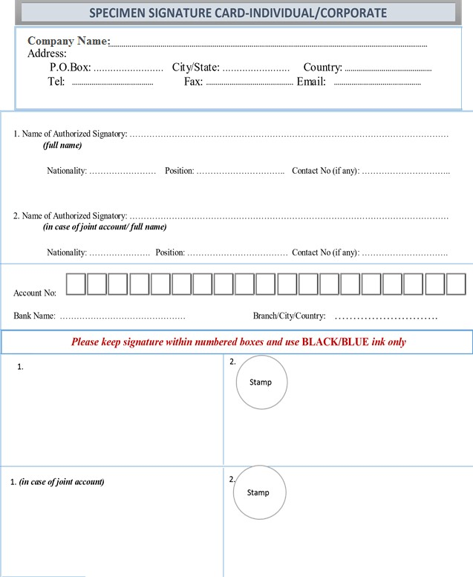

CUSTOMER OFFICIAL TO BE CONTACTED FOR PAYMENT
Name | Designation | Contact No.
TRADE REFERENCES
(Please specify three suppliers with whom you have credit account)

Name | Designation | Contact No.
AGREEMENT CONDITIONS

- All goods must be verified and approved on delivery of the same with the acknowledgement from your organization with your company seal.
- Payment of invoices will be made in accordance with the credit terms as mutually agreed
- Payment cannot be withheld for non-receipt of statement of account
- This credit Application must be signed by the owner of the firm otherwise a copy of the Power of Attorney from the owner must be attached for such authorized signatory powers.
- The customer undertakes to honor the cheques (current or post-dated) on the due date without any prejudice to any other condition of sale or otherwise. Late payment charges, at the sole discretion of the management, will be levied on payments after the due date.
- Any Changes in the above information should be informed to Omnia Food Trading as and when it occurs.
- On expiry of all relevant documents, the same will be replaced with a copy of the renewed copy.
- Non-compliance of the above conditions will render the application invalid and the contract will be terminated.
- Company reserves the right to accept or reject the application without assigning reason whatsoever.
- 10 % Penalty shall be imposed on the amount of dishonored cheque from the bank.

I/We agree to the above conditions and declare that all information given in this application are true and correct.

 | SIGNATURES & COMPANY STAMP
Signature |  | Signature
Name and Title |  | Name and Title
Date |  | Date

Please attach the following copies of documents with filled in application form:
- Passport copy of owner with Visa page.
- Passport copy of sponsor.
- Current trade license and Chamber of Commerce Copy.
- Power of attorney.
 | OFFICE USE ONLY | Approved by (Manager) Proposed by (Sales Executive) Verified by
  Singly/Jointly

